**Retrieve event information**

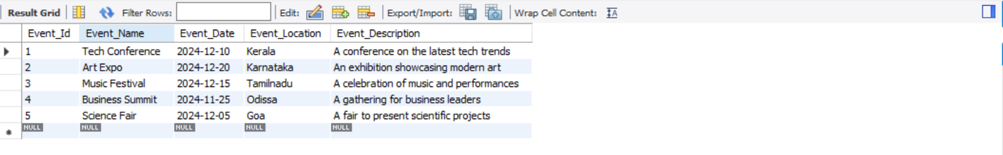

**Generate attendee lists for Events**

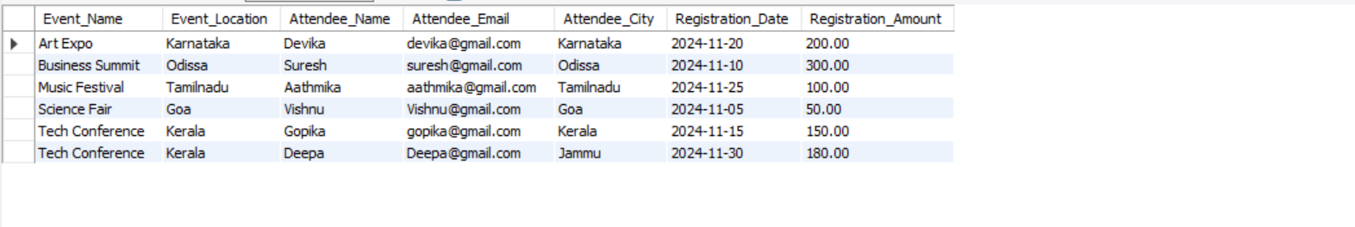

**Calculate event attendance statistics**

